UPS Developer API: Request Access Key
*An Access Key is needed if you have negotiated rates with UPS.
Browse to http://www.ups.com.
- Log in with your User ID and password. If you do not have a UPS.com User ID and password, click on the New User link at the top of the page and follow the prompts to complete the registration process.
Please note: If you have already registered for My UPS.com, we recommend you create a new user ID and password for use with UPS Developer APIs.

- Hover over the "Support" tab near the top of the page and then click on "Technology Support."

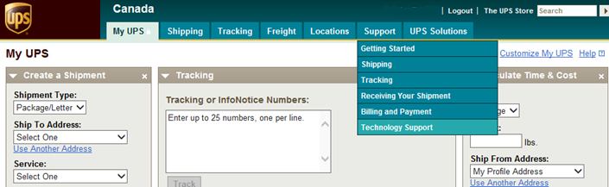

- Click the "UPS Developer Kit" link, located in the Tools and Resources section.

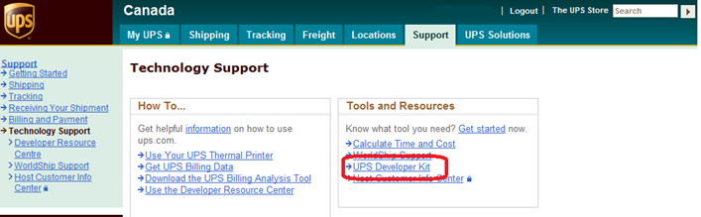

- Click on the "Request an access key" link, located in the How to Get Started section.

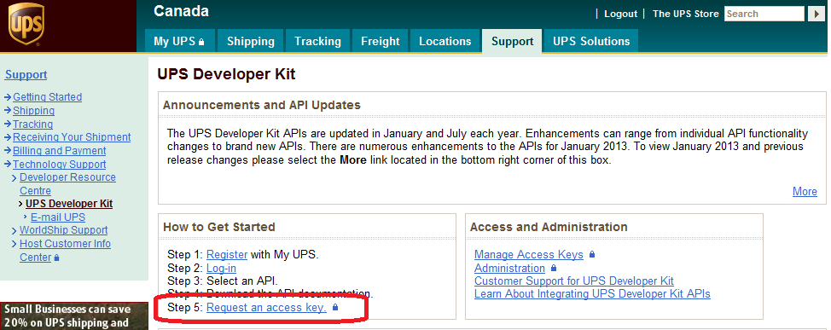
6.) Complete the "Secondary Contact Information" section.
7.) Select the account number you wish to associate with the Access Key.
8.) Click the "Request Access Key" button.
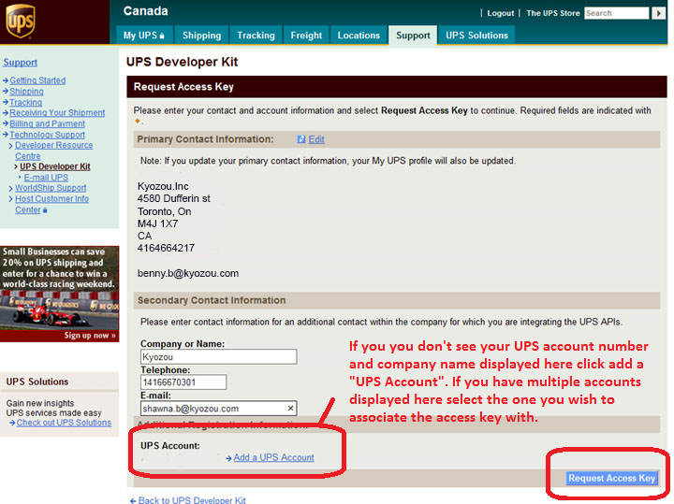
9. The Access Key and the access type for each Developer API will be displayed. This information will also be emailed to you.
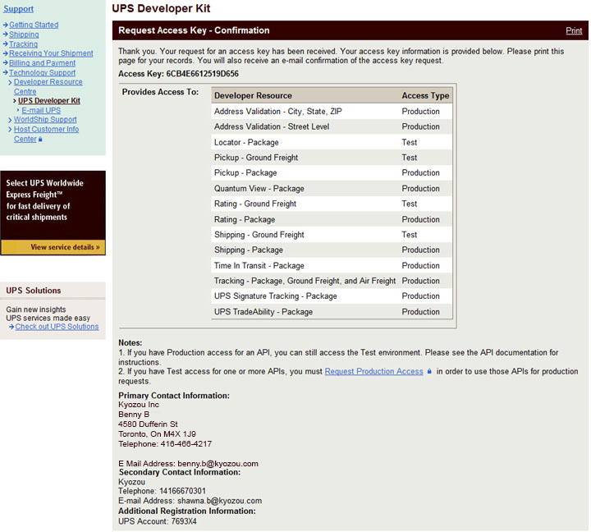

UPS Developer API: Request Production Access
*All API’s except those for UPS Freight and UPS Location Tracker are enabled by default and do not require you to request production access. If you will be shipping items over 150 pounds you will want to request production access to enable negotiated rates on freight options, otherwise this will not apply.
Browse to http://www.ups.com.
- Log in with your User ID and password. If you do not have a UPS.com User ID and password, click on the New User link at the top of the page and follow the prompts to complete the registration process.
Please note: If you have already registered for My UPS.com, we recommend you create a new user ID and password for use with UPS Developer APIs.

- Hover over the "Support" tab near the top of the page and then click on "Technology Support."

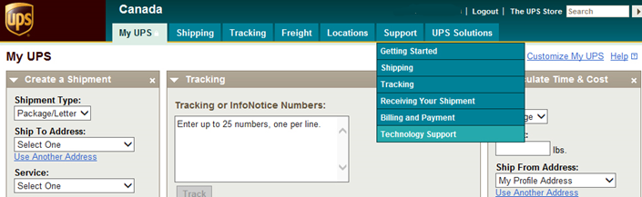
- Click the "UPS Developer Kit" link, located in the Tools and Resources section.
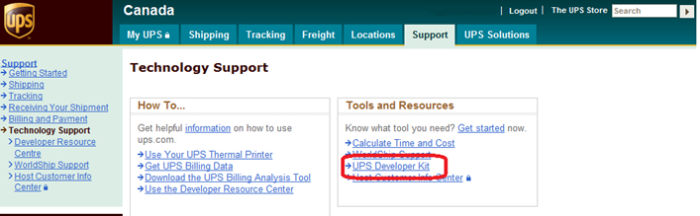
- Click “Manage Access Keys” link, located in the Access and Administration section.
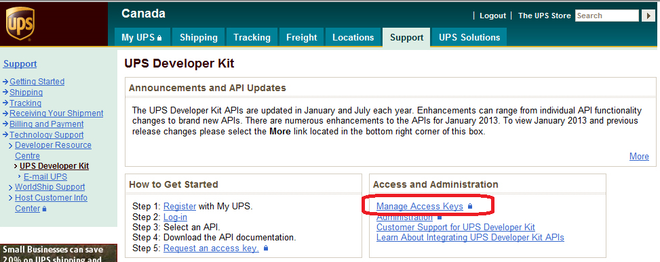
5.) Enter Access Key you are requesting production access for.
6.) Click “Request Production Access.”
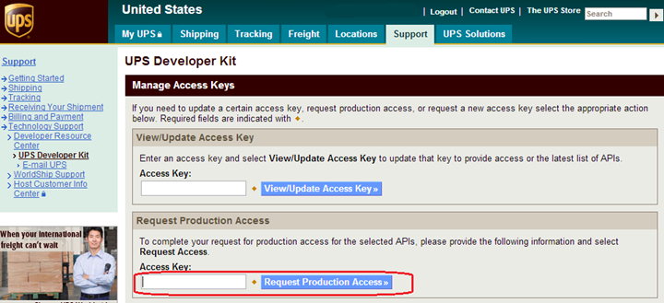
7.) Select the APIs you wish to request production access for.
8.) Click the “Next” button.
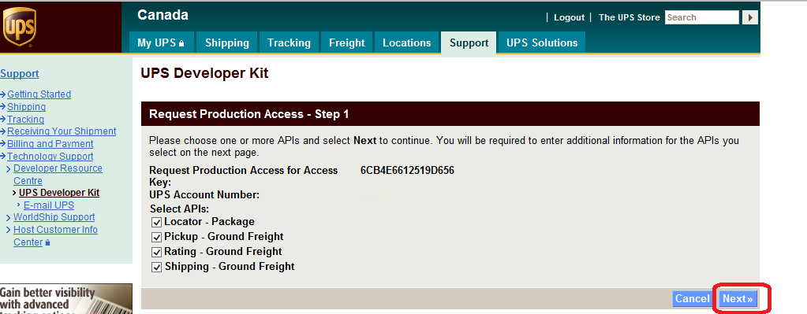
9.) Enter the following fields:
Pick up Confirmation Number
Bill of landing number
Rate value
10.) Click the “Request Access” button.
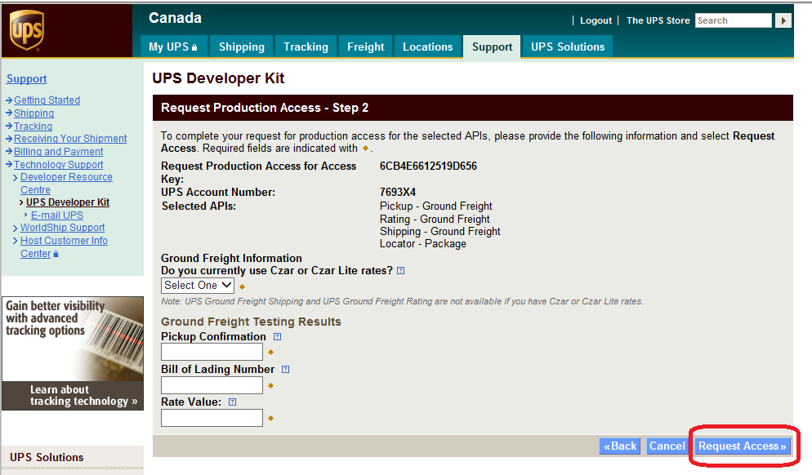
UPS Account Authentication
*Your UPS account must be authenticated in order for the Access Key to pull negotiated rates. To check to see if your account is authenticated or to authenticate a new account, follow the steps below.
Browse to http://www.ups.com.
- Log in with your User ID and password. If you do not have a UPS.com User ID and password, click on the New User link at the top of the page and follow the prompts to complete the registration process.

- Go to My UPS and Maintain Your UPS Account

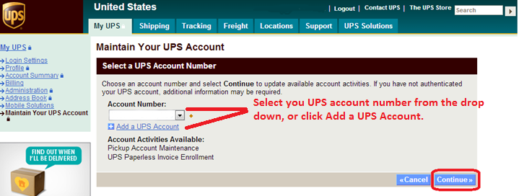
3.) If the account is not authenticated you will see the screen below, you will also need to have a copy of a recent UPS invoice to complete the authentication. Fill in the following fields:
Invoice Number
Charges/Amount Due
Invoice Date
Control ID
*Note Control ID is only found on the paper copy of your UPS invoice.
4.) Click the “Next” button.
